**Title: Effect of high flow nasal cannula versus nasal continuous positive airway pressure on clinical outcomes of preterm infants with Respiratory distress syndrome**

**Running title: HFNC vs. NCPAP in Preterm RDS Outcomes**

**Abstract**

**Background:** Respiratory distress syndrome (RDS) is a severe problem for premature babies. Non-invasive respiratory support techniques including high-flow nasal cannula (HFNC) and nasal continuous positive airway pressure (nCPAP) are frequently used, although clinical evidence remain insufficient.

**Patients and Methods:** A randomized controlled trial was conducted involving 100 preterm infants (28–36 weeks gestation) diagnosed with RDS. Patients were randomly assigned to receive either (HFNC; n=50) or (nCPAP; n=50) as primary respiratory support. Primary outcomes included the duration of respiratory support and supplemental oxygen therapy. Secondary outcomes encompassed feeding tolerance, length of hospital stay, complications, and mortality.

**Results:** Baseline characteristics were comparable between groups. HFNC group demonstrated significantly shorter duration of respiratory support (5.42±2.18 vs 6.87±3.12 days, p=0.045), supplemental oxygen therapy (10.54±4.12 vs 12.98±5.20 days, p=0.030), and hospital stay (8.36±3.63 vs 13.22±5.63 days, p<0.001). Earlier feeding initiation (2.1±0.9 vs 3.5±1.1 days, p=0.030) and faster progression to full feeds (9.2±3.4 vs 11.6±3.8 days, p=0.007) were observed with HFNC. Complication rates were consistently lower in the HFNC group, including nasal trauma (6% vs 16%), pneumonia (4% vs 12%), and bronchopulmonary dysplasia (10% vs 20%), though not statistically significant. Mortality rates were similar (12% vs 18%, p=0.401).

**Conclusion:** HFNC demonstrated superior outcomes compared to nCPAP in preterm infants with RDS, with significantly shorter respiratory support duration, hospital stay, and improved feeding tolerance while maintaining comparable safety profiles.

**Keywords:** High-flow nasal cannula, nasal continuous positive airway pressure, preterm infants, respiratory distress syndrome, non-invasive ventilation, feeding tolerance

**Introduction**

RDS is one of the leading causes of morbidity and mortality in preterm infants due to surfactant deficiency and undeveloped lungs. Effective respiratory support is critical in its management, especially among neonates born before 37 weeks of gestation (1). Traditionally, nCPAP has been widely used as a primary mode of non-invasive ventilation (NIV) for these infants, showing benefits in maintaining functional residual capacity and reducing the need for mechanical ventilation (2).

Recently, HFNC has emerged as an alternative mode of respiratory support. HFNC delivers heated, humidified oxygen at high flow rates and is considered to be less invasive and more comfortable for neonates, with easier application and potentially lower risk of nasal trauma (3). Several studies have examined its effectiveness compared to nCPAP, but clinical evidence regarding outcomes such as duration of respiratory support, oxygen dependence, feeding tolerance, complications, and mortality remains mixed and context-dependent (4-6).

This study aimed to compare the clinical outcomes of HFNC versus nCPAP in the management of preterm infants with RDS, focusing on respiratory efficiency, feeding progression, complication rates, and final outcomes. By evaluating these parameters, we seek to provide evidence to support optimal, individualized respiratory care in neonatal intensive care units.

**Materials and Methods**

**Study Design and Setting**

This prospective cross-sectional study compared the clinical outcomes of preterm RDS infants treated with HFNC or nCPAP. The Neonatal Intensive Care Unit (NICU) at Assiut University Children Hospital, a tertiary care hospital for high-risk neonates, particularly preterm infants, hosted the study from June 2022 to June 2023.

**Study Population**

We randomized 100 preterm infants who met the inclusion criteria into two equal groups (n=50 each). The sample size was estimated using a power calculation with α = 0.05, power = 80%, 5% predicted attrition, and a medium effect size (Cohen's d = 0.37). Participants were not lost to follow-up. Figure (1) shows the study's participant flow.

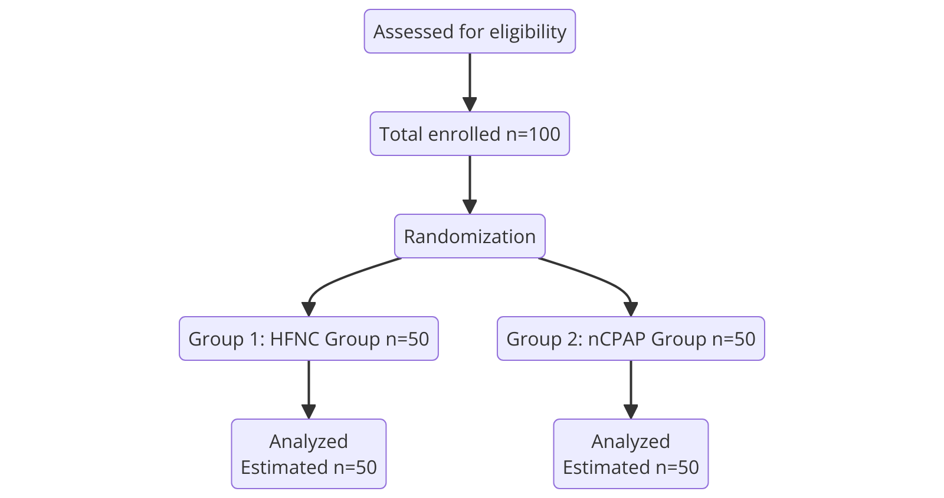

**Figure 1.** CONSORT flow diagram

**Inclusion Criteria**

* Preterm infants with gestational age ≥30 weeks
* Birth weight >1000 grams
* Clinical diagnosis of RDS, based on:
  + Signs of respiratory distress (retractions, grunting, nasal flaring)
  + Hypoxia requiring supplemental oxygen (SpO₂ monitoring)
  + Radiographic evidence (diffuse haziness, air bronchograms)
  + Abnormal blood gases (acidosis, hypoxemia, hypercapnia) [(Jobe, 2014)]

**Exclusion Criteria**

* Term infants (>37 weeks)
* Gestational age <30 weeks and/or birth weight <1000 grams
* Respiratory distress due to causes other than RDS
* Diagnosed neonatal sepsis or congenital anomalies (including congenital heart defects)
* Requirement for immediate invasive mechanical ventilation after birth

**Intervention Groups**

Participants were allocated into two intervention groups:

**Group 1: HFNC Group *(3).***

Infants in this group received warmed and humidified oxygen via high flow nasal cannula. Flow rates ranged from 2 to 8 L/min based on weight and clinical condition. FiO₂ was titrated according to oxygenation status. Cannulas were fitted to ensure comfort and minimal leak, using a heated humidifier for mucosal protection.

**Group 2: nCPAP Group *(2)***.

Infants received continuous positive airway pressure using nasal prongs or mask. Pressure settings ranged from 4 to 6 cm H₂O, adjusted as needed. FiO₂ was individualized. A heated humidifier was used to maintain airway humidity.

Groups were matched for sex, gestational age, birth weight, mode of delivery, RDS severity, and surfactant administration to minimize confounding.

**Data Collection**

**I. Clinical and Demographic Data**

* **Neonatal parameters**: Sex, gestational age, birth weight, delivery mode, Apgar scores (1 and 5 min), need for resuscitation, surfactant use, consanguinity
* **Maternal factors**: Age, parity, antenatal steroid use, and maternal complications (e.g., preeclampsia, chorioamnionitis, anemia, PROM, gestational diabetes, placenta previa, cord prolapse)

**II. Respiratory and Feeding Data**

• Time to start and length of non-invasive ventilation

• Success/failure of NIV (depending on mechanical ventilation)

• Length of supplemental oxygen

• Length of hospital stay

• Start of enteral feeding

• Full feedsFeeding intolerance (e.g., stomach distension)

• Weight gain

**III. Complications**

Complications recorded included nasal trauma, apnea, pneumonia, bronchopulmonary dysplasia (BPD), intraventricular hemorrhage (IVH), retinopathy of prematurity (ROP), necrotizing enterocolitis (NEC), and neonatal sepsis.

**IV. Investigations**

* **Laboratory**: Blood glucose, CRP, CBC (WBC, Hb, HCT, PLT, neutrophils, lymphocytes), serum electrolytes (Na⁺, K⁺, Ca²⁺), kidney function (urea, creatinine), arterial blood gases (pH, PCO₂, HCO₃)
* **Radiological**: Chest X-ray grading of RDS severity (Grades I–III)

**Statistical Analysis**

Data was analyzed using SPSS 28. Continuous variables were compared between groups using the independent samples t-test, expressed as mean ± SD. Categories were reported as frequencies and percentages, and Chi-square or Fisher's exact tests were used to compare them. A p-value < 0.05 indicated statistical significance.

**Ethical Considerations**

The Assiut University Children Hospital Ethics Committee approved the study (IRB No. 04-2023-200204). All enrolled newborns' parents gave written informed permission. No experimental interventions were used because HFNC and nCPAP are RDS conventional therapies. In the study, participant confidentiality and data privacy were strictly observed.

**Results**

**Table 1: Demographic and Maternal Risk Factors characteristics of the studied groups.**

|  |  |  |  |
| --- | --- | --- | --- |
| **Variable** | **HFNC Group (N=50)** | **nCPAP Group (N=50)** | **p-value** |
| **Gender** |  |  |  |
| Male | 29 (58.0%) | 22 (44.0%) | 0.230 |
| Female | 21 (42.0%) | 28 (56.0%) | 0.760 |
| **Gestational Age (weeks)** | 32.48 ± 1.59 | 32.38 ± 1.68 | 0.973 |
| 30–32 weeks GA | 37 (74.0%) | 33 (66.0%) | 0.629 |
| 33–36 weeks GA | 13 (26.0%) | 17 (34.0%) |  |
| **Birth Weight (kg)** | 1.68 ± 0.39 | 1.60 ± 0.40 | 0.265 |
| **Mode of Delivery** |  |  | 0.978 |
| Emergency CS | 27 (54.0%) | 29 (58.0%) |  |
| Elective CS | 20 (40.0%) | 19 (38.0%) |  |
| NVD | 3 (6.0%) | 2 (4.0%) |  |
| **Resuscitation at Birth** | 7 (14.0%) | 13 (26.0%) | 0.135 |
| **Apgar Score** |  |  |  |
| 1 min | 4.18 ± 1.34 | 4.70 ± 1.42 | 0.736 |
| 5 min | 6.86 ± 0.97 | 7.12 ± 1.29 | 0.234 |
| **Surfactant Administration** | 16 (32.0%) | 24 (48.0%) | 0.056 |
| **Consanguinity** |  |  | 0.277 |
| Yes | 26 (52.0%) | 19 (38.0%) |  |
| No | 24 (48.0%) | 31 (62.0%) |  |
| **Maternal Age (years)** | 27.46 ± 5.33 | 26.32 ± 5.36 | 0.288 |
| **Parity** |  |  | 0.946 |
| Single | 21 (42.0%) | 25 (50.0%) |  |
| Multiple | 29 (58.0%) | 25 (50.0%) |  |
| **Antenatal Steroid Use** |  |  | 0.097 |
| Yes | 11 (22.0%) | 9 (18.0%) |  |
| No | 39 (78.0%) | 41 (82.0%) |  |
| **Maternal Risk Factors** |  |  |  |
| Preeclampsia | 25 (50.0%) | 20 (40.0%) | 0.315 |
| Chorioamnionitis | 12 (24.0%) | 10 (20.0%) | 0.629 |
| Anemia | 10 (20.0%) | 15 (30.0%) | 0.248 |
| PROM | 3 (6.0%) | 2 (4.0%) | 0.646 |
| Gestational Diabetes | 2 (4.0%) | 3 (6.0%) | 0.646 |
| Placenta Previa | 0 (0.0%) | 1 (2.0%) | 0.499 |
| Cord Prolapse | 0 (0.0%) | 1 (2.0%) | 0.315 |

**Abbreviation.** CS: Cesarean Section, NVD: Normal Vaginal Delivery. HTN: Hypertension, PROM: Premature Rupture of Membranes

Data represent as Mean ± SD or number (percentage).

p: p value for comparing between the two studied groups. *: Statistically significant at p ≤ 0.05

Table (1) illustrates the groups' baseline characteristics. Gender, gestational age, birth weight, mode of delivery, resuscitation at birth, Apgar scores, surfactant administration, and consanguinity did not differ between HFNC and nCPAP groups. Groups had similar maternal age, parity, prenatal steroid use, and risk variables.

**Table 2: Respiratory and Feeding Outcomes** **of the studied groups.**

|  |  |  |  |
| --- | --- | --- | --- |
| **Variable** | **HFNC Group (N=50)** | **nCPAP Group (N=50)** | **p-value** |
| **Respiratory Outcomes** |  |  |  |
| Time of Initiation of Respiratory Support (days) | 1.54 ± 0.74 | 1.98 ± 0.84 | 0.149 |
| Duration of Respiratory Support (days) | 5.42 ± 2.18 | 6.87 ± 3.12 | 0.045 * |
| Successful Weaning of NIV | 40 (80.0%) | 35 (70.0%) | 0.250 |
| Need for Mechanical Ventilation | 7 (14.0%) | 13 (26.0%) | 0.135 |
| Duration of Supplemental O₂ (days) | 10.54 ± 4.12 | 12.98 ± 5.20 | 0.030 * |
| Hospital Stay Duration (days) | 8.36 ± 3.63 | 13.22 ± 5.63 | <0.001* |
| **Feeding Outcomes** |  |  |  |
| Time to Start Feeding (days) | 2.1 ± 0.9 | 3.5 ± 1.1 | 0.030 * |
| Time to Reach Full Feeds (days) | 9.2 ± 3.4 | 11.6 ± 3.8 | 0.007 * |
| Feeding Intolerance | 8 (16.0%) | 12 (24.0%) | 0.305 |
| Weight Gain (g) | 21.5 ± 5.3 | 19.8 ± 5.9 | 0.150 |

**Abbreviation.** NIV: Noninvasive Ventilation

Data represent as Mean ± SD or number (percentage).

p: p value for comparing between the two studied groups. *: Statistically significant at p ≤ 0.05

Table (2) represents a comparison of respiratory and feeding outcomes. The HFNC group had significantly shorter durations of respiratory support (p=0.045), supplemental oxygen (p=0.030), and hospital stay (p<0.001). Time to initiate feeding and time to reach full enteral feeds were also significantly shorter in the HFNC group (p=0.030 and p=0.007, respectively). No significant differences were observed in feeding intolerance, weight gain, successful weaning, or need for mechanical ventilation.

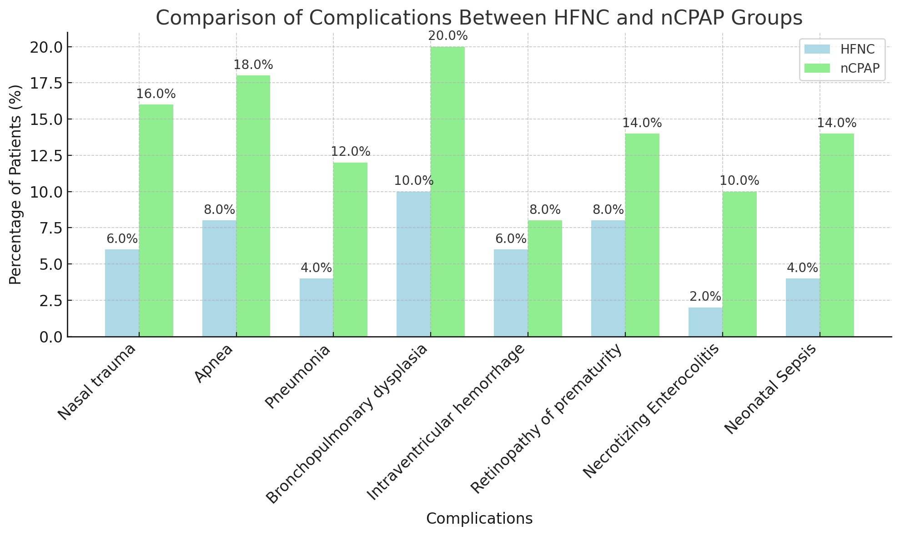

Figure (2): Comparison between the studied groups regarding complications.

Figure 2 shows complication rates for 100 preterm infants (50 HFNC, 50 nCPAP). The HFNC group consistently showed lower rates across all complications, including nasal trauma (6% vs 16%), apnea (8% vs 18%), pneumonia (4% vs 12%), bronchopulmonary dysplasia (10% vs 20%), necrotizing enterocolitis (2% vs 10%), and neonatal sepsis (4% vs 14%), but without a statistical significant differences between the two groups.

**Table 3: Complications and Laboratory Findings of the studied groups.**

| **Variable** | **HFNC Group (N=50)** | **nCPAP Group (N=50)** | **p-value** |
| --- | --- | --- | --- |
| **Blood glucose (mg/dl)** | 105.96 ± 27.37 | 96.56 ± 24.25 | 0.096 |
| **CRP (mg/dl)** | 0.23 ± 0.03 | 0.19 ± 0.01 | 0.529 |
| **CBC** |  |  |  |
| WBC (×10³/µL) | 14.84 ± 20.59 | 12.02 ± 6.89 | 0.287 |
| HB (g/dL) | 14.64 ± 3.12 | 15.58 ± 2.86 | 0.139 |
| Hematocrit (%) | 47.43 ± 31.03 | 45.09 ± 9.24 | 0.596 |
| Platelets (×10³/µL) | 231.92 ± 92.46 | 249.6 ± 97.92 | 0.386 |
| Segmented Neutrophils (%) | 45.85 ± 16.37 | 43.75 ± 15.69 | 0.537 |
| Lymphocytes (%) | 38.09 ± 15.95 | 38.55 ± 13.67 | 0.870 |
| **Serum electrolyte** |  |  |  |
| Serum Na (mmol/L) | 140.68 ± 4.95 | 139.3 ± 3.63 | 0.298 |
| Serum K (mmol/L) | 4.73 ± 0.71 | 4.72 ± 0.71 | 0.947 |
| Serum Ca+2 (mg/dL) | 8.59 ± 0.96 | 8.59 ± 1.17 | 0.987 |
| **Kidney function test** |  |  |  |
| Serum urea (mg/dL) | 23.65 ± 18.52 | 29.31 ± 9.23 | 0.178 |
| Serum creatinine (mg/dL) | 0.58 ± 0.23 | 0.51 ± 0.21 | 0.161 |
| **ABG** |  |  |  |
| PH | 7.37 ± 0.23 | 7.33 ± 0.14 | 0.372 |
| PCO2 (mmHg) | 33.13 ± 10.69 | 37.39 ± 15.51 | 0.133 |
| HCO3 (mmol/L) | 23.34 ± 6.27 | 20.67 ± 9.49 | 0.152 |

**Abbreviation.** CBC: Complete Blood Count, WBC: White Blood Cells, HB: Hemoglobin, Na: Sodium, K: Potassium, Ca+2: Calcium, ABG: Arterial Blood Gas, PCO2: Partial Pressure of Carbon Dioxide, HCO3: Bicarbonate

Data represent as Mean ± SD.

p: p value for comparing between the two studied groups. *: Statistically significant at p ≤ 0.05

Table (3) shows Laboratory findings, including blood glucose, CRP, CBC, electrolytes, renal function, and arterial blood gases, showed no significant differences between groups.

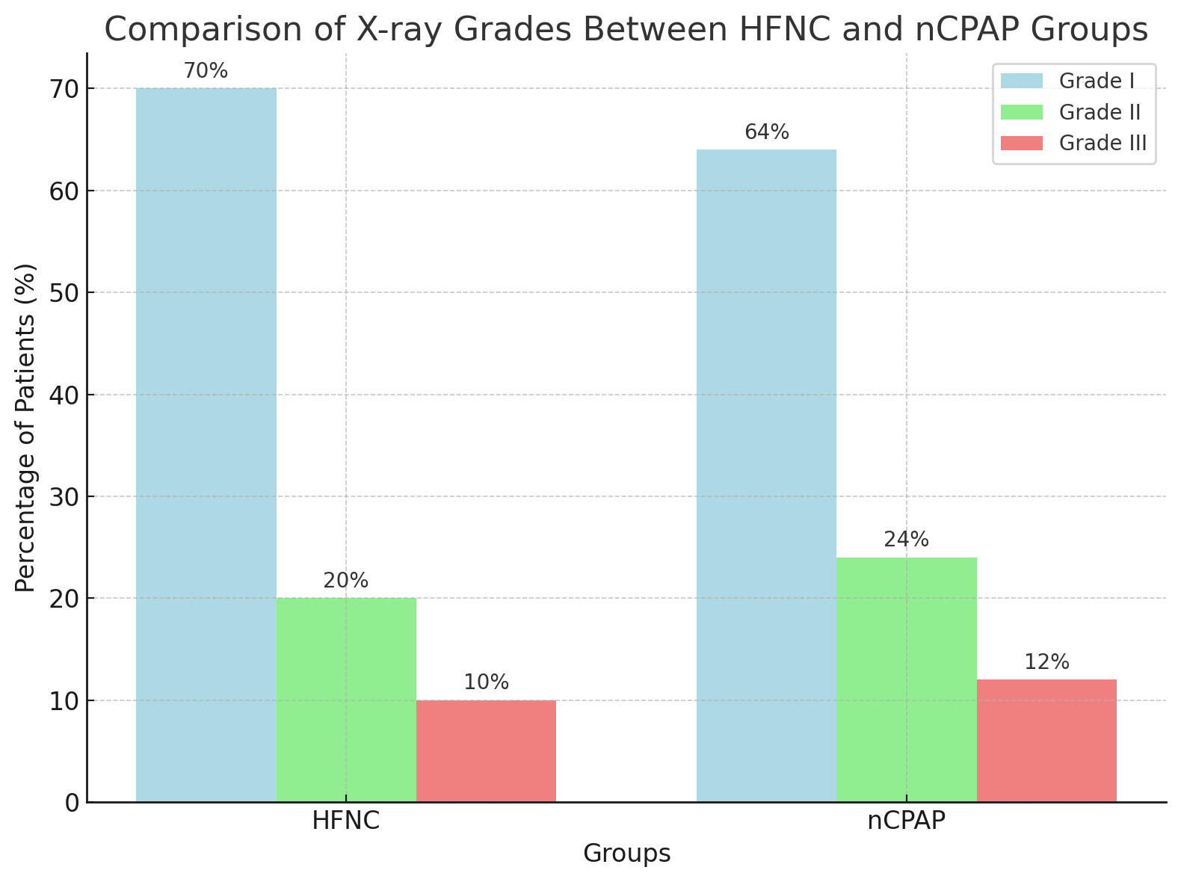

**Figure (3): Comparison between the studied groups regarding chest x rays) findings.**

Radiological findings for 100 preterm infants (50 HFNC, 50 nCPAP). No statistically significant differences were found in the distribution of radiological grades between the two groups (p=0.673). The majority of infants in both groups had Grade I findings (HFNC: 70%, nCPAP: 64%). Grade II findings were observed in 20% of HFNC and 24% of nCPAP infants, while Grade III findings were seen in 10% of HFNC and 12% of nCPAP infants (Figure 3).

**Table 4: Final Outcomes of the studied groups.**

| **Variable** | **HFNC Group (N=50)** | **nCPAP Group (N=50)** | **p-value** |
| --- | --- | --- | --- |
| **Final Clinical Outcome** |  |  |  |
| Died | 6 (12.0%) | 9 (18.0%) | 0.401 |
| Discharged | 44 (88.0%) | 41 (82.0%) |  |

Data represent as number (percentage).

p: p value for comparing between the two studied groups or within group. *: Statistically significant at p ≤ 0.05

Table (4) shows mortality was lower in the HFNC group (12% vs. 18%), but this difference was not statistically significant (p=0.401).

**Discussion**

This randomized controlled trial comparing HFNC versus nCPAP in preterm infants with RDS demonstrates several clinically significant advantages of HFNC, particularly in resource utilization and feeding outcomes, while maintaining comparable safety profiles.

The finding of significantly shorter respiratory support duration in the HFNC group (5.42 vs 6.87 days, p=0.045) aligns with Luo et al. (7), who found HFNC was associated with shorter oxygen therapy duration compared to nCPAP (SMD = −0.35, 95% CI: −0.68 to −0.02). However, this contrasts with Uchiyama et al. (8), who reported that HFNC might require slightly longer non-invasive support post-extubation. The significantly shorter supplemental oxygen duration in our HFNC group (10.54 vs 12.98 days, p=0.030) may be attributed to HFNC's superior comfort and ease of use for moderately ill infants (7).

While the present work showed numerically higher success rates for HFNC (80% vs 70% successful weaning), this difference was not statistically significant, consistent with Singh et al. (9), who concluded HFNC was non-inferior to nCPAP with comparable failure rates. Similarly, Zhu et al. (10) found no significant difference between modalities in weaning success and mechanical ventilation needs. A study Zhu et al. (10), who reported lower mechanical ventilation incidence with HFNC, especially in 26-29 week infants, support the result toward lower mechanical ventilation requirements in our HFNC group (14% vs 26%).

Our most interesting finding was significantly shorter hospitalization in the HFNC group (8.36 vs 13.22 days, p<0.001), representing a 37% reduction. This is supported by Luo et al. (7), who reported shorter hospital stays with HFNC (mean difference: −3.2 days, 95% CI: −4.8 to −1.6). However, Uchiyama et al. (8) and Zhu et al. (10) found no significant differences, suggesting results may vary based on healthcare systems and discharge criteria. This substantial reduction has important implications for healthcare economics and family dynamics.

In the current study, the significantly earlier enteral feeding initiation in the HFNC group (2.1 vs 3.5 days, p=0.030) and faster progression to full feeds (9.2 vs 11.6 days, p=0.007) represent clinically important advantages. This may reflect better respiratory stability with HFNC, as lower pressure delivery interferes less with gastric emptying. These findings are consistent with Walsh et al. (11) and Razzaghy et al. (12), who found early feeding protocols improved gastrointestinal tolerance. Boscarino et al. (13) similarly reported that early enteral feeding reduced complications in HFNC-supported infants.

The lower nasal trauma rate in our HFNC group (6% vs 16%), while not statistically significant in our results, aligns with Luo et al. (7), who reported significantly lower nasal trauma with HFNC (RR = 0.36, 95% CI: 0.29–0.45). Lower apnea rates (8% vs 18%) align with Iranpour et al. (14), who found non-invasive ventilation reduced apnea episodes when combined with prophylactic caffeine.

Although pneumonia (4% vs 12%) and BPD rates (10% vs 20%) were numerically lower with HFNC, differences were not statistically significant. Pan et al. (15) similarly reported no significant differences in BPD rates between non-invasive ventilation modalities. The similar rates of IVH (6% vs 8%) and ROP (8% vs 14%) are consistent with Sorokina & Bolonska (16), who indicated that prolonged respiratory support duration increases these risks.

Lower rates of NEC (2% vs 10%) and neonatal sepsis (4% vs 14%), while not statistically significant, may relate to earlier feeding establishment. Shen et al. (17) reported that early enteral feeding and appropriate antibiotic use were associated with reduced NEC risk.

In the current study , the comparable blood glucose levels, electrolyte balance, and kidney function between groups indicate both modalities maintain physiological homeostasis effectively. Our findings align with Sayed et al. (18) regarding glucose levels and Stritzke et al. (19) regarding electrolyte balance. Similar CRP levels and CBC parameters, as reported by Kadi et al. (20), suggest minimal differential impact on inflammatory responses. The comparable ABG parameters indicate both modalities provide adequate ventilation, supported by Uchiyama et al. (21).

The comparable RDS severity distribution indicates similar efficacy across disease severities. Singh et al. (9) and Wang et al. (22) similarly reported no significant differences in radiological findings between modalities. The numerically lower mortality in our HFNC group (12% vs 18%) is consistent with Li et al. (23), Mukerji et al. (24), and Zhu et al. (10), who reported comparable mortality rates between modalities.

The current well-balanced demographics support study validity. The mean gestational age of 32.4 weeks aligns with Qian et al. (25), who noted that infants <32 weeks often require intensive respiratory support. Higher emergency cesarean rates reflect acute delivery complications, as noted by Lin et al. (26). Maternal characteristics were comparable, consistent with Shin et al. (27) and Murki et al. (28). The distribution of maternal risk factors aligned with Bruet et al. (29) and Armanian et al. (30).

**Conclusions**

In conclusion, HFNC and nCPAP are effective non-invasive respiratory support modalities for preterm infants with RDS. HFNC was associated with shorter durations of respiratory support, oxygen supplementation, and hospitalization, as well as better feeding outcomes. These findings suggest that HFNC can be a suitable alternative to nCPAP for respiratory support in preterm infants with RDS.

**Availability of Data and Materials:**

Contact the associated author for this work's data collection.

**Declaration of Conflicting Interests:** No conflicts of interest have been revealed about this article's research, authorship, or publishing.

**Funding:** The authors received no financial support for the research, authorship, or publication of this article.

**References**

1. De Luca D, Autilio C, Pezza L, Shankar-Aguilera S, Tingay DG, Carnielli VP. Personalized medicine for the management of RDS in preterm neonates. Neonatology. 2021;118(2):127-38.
2. Jat KR, Mathew JL. Continuous positive airway pressure (CPAP) for acute bronchiolitis in children. Cochrane database of systematic reviews. 2015(1).
3. Nolasco S, Manti S, Leonardi S, Vancheri C, Spicuzza L. High-flow nasal cannula oxygen therapy: physiological mechanisms and clinical applications in children. Frontiers in medicine. 2022;9:920549.
4. Zhao X, Qin Q, Zhang X. Outcomes of high-flow nasal cannula vs. nasal continuous positive airway pressure in young children with respiratory distress: a systematic review and meta-analysis. Frontiers in Pediatrics. 2021;9:759297.
5. Cresi F, Maggiora E, Lista G, Dani C, Borgione SM, Spada E, et al. Effect of nasal continuous positive airway pressure vs heated humidified high-flow nasal cannula on feeding intolerance in preterm infants with respiratory distress syndrome: the ENTARES randomized clinical trial. JAMA Network Open. 2023;6(7):e2323052-e.
6. Luo K, Huang Y, Xiong T, Tang J. High-flow nasal cannula versus continuous positive airway pressure in primary respiratory support for preterm infants: a systematic review and meta-analysis. Frontiers in pediatrics. 2022;10:980024.
7. Luo K, Huang Y, Xiong T, Tang J. High-flow nasal cannula versus continuous positive airway pressure in primary respiratory support for preterm infants: a systematic review and meta-analysis. Frontiers in Pediatrics. 2022;10:980024.
8. Uchiyama A, Ochiai S, Murayama Y. Noninvasive respiratory support following extubation in preterm infants. Pediatrics International. 2023;65:e15535.
9. Singh S, Ananthan A, Nanavati R. Post-INSURE administration of heated humidified high-flow therapy versus nasal continuous positive airway pressure in preterm infants more than 28 Weeks gestation with respiratory distress syndrome: a randomized non-inferiority trial. Journal of Tropical Pediatrics. 2022;68:fmac062.
10. Zhu X, Qi H, Feng Z, Li J, Shi Y, Zhao D. Noninvasive high-frequency oscillatory ventilation vs nasal continuous positive airway pressure vs nasal intermittent positive pressure ventilation as postextubation support for preterm neonates in China: a randomized clinical trial. JAMA Pediatrics. 2022;176:551-559.
11. Walsh V, Brown JV, Copperthwaite BR, Oddie SJ, McGuire W. Early full enteral feeding for preterm or low birth weight infants. Cochrane Database of Systematic Reviews. 2020(12).
12. Razzaghy J, Shukla VV, Gunawan E, Christensen RD, Carey WA. Early and exclusive enteral nutrition in infants born very preterm. Archives of Disease in Childhood-Fetal and Neonatal Edition. 2024;109:378-383.
13. Boscarino G, Conti MG, Di Chiara M. Early enteral feeding improves tolerance of parenteral nutrition in preterm newborns. Nutrients. 2021;13:3886.
14. Iranpour R, Armanian AM, Miladi N. Effect of prophylactic caffeine on noninvasive respiratory support in preterm neonates weighing 1250–2000 g: a randomized controlled trial. Archives of Iranian Medicine. 2022;25:98-104.
15. Pan R, Chen GY, Wang J, Zhang J. Bi-level nasal positive airway pressure (BiPAP) versus nasal continuous positive airway pressure (CPAP) for preterm infants with birth weight less than 1500 g and respiratory distress syndrome following INSURE treatment: a two-center randomized controlled trial. Current Medical Science. 2021;41:542-547.
16. Sorokina OY, Bolonska AV. Predictors of bronchopulmonary dysplasia development and comorbidities of prematurity associated with respiratory support techniques in premature neonates. Wiad Lek. 2021;74:1699-1706.
17. Shen R, Embleton N, Forman JL, Gale C, Greisen G, Sangild PT, Uthaya S, Berrington J. Early antibiotic use and incidence of necrotising enterocolitis in very preterm infants: a protocol for a UK based observational study using routinely recorded data. BMJ open. 2022 Nov 1;12(11):e065934.
18. Sayed MA, Begum F, Islam SN. Comparative study of Serum Creatinine and Serum Glucose Level between Term and Preterm Neonates in a Tertiary Care Hospital. TAJ: Journal of Teachers Association. 2021;34:64-70.
19. Stritzke A, Ismail R, Rose MS, et al., Cord-blood derived chemistry reference values in preterm infants for sodium, chloride, potassium, glucose, and creatinine. American Journal of Perinatology. 2024 Apr;41(06):722-9.
20. Kadi FA, Yuniati T, Sribudian Y. C-reactive protein and haemoglobin level in acute kidney injury among preterm newborns. Med Glas (Zenica). 2021;18:410-414.
21. Uchiyama A, Okazaki K, Kondo M, Hibino S, Gotoh S, Nishida K. Randomized controlled trial of high-flow nasal cannula in preterm infants after extubation. Pediatrics. 2020;146.
22. Wang JJ, Zhang L, Cai N. A comparative study of the efficacy and safety of high-flow nasal cannula and nasal continuous positive airway pressure in neonatal respiratory distress syndrome: A protocol for systematic review and meta-analysis. Medicine. 2022;101:e29109.
23. Li Y, Zhu X, Shi Y. Non-invasive high-frequency oscillatory ventilation versus nasal continuous positive airway pressure in extremely preterm infants with respiratory distress syndrome: study protocol for a multicentre randomised controlled, superiority trial. BMJ Open. 2023;13:e068450.
24. Mukerji A, Rempel E, Thabane L. High continuous positive airway pressures versus non-invasive positive pressure ventilation in preterm neonates: protocol for a multicentre pilot randomised controlled trial. BMJ Open. 2023;13:e069024.
25. Qian M, Yu ZB, Chen XH, Wu XQ, Tang RM. Clinical features of preterm infants with a birth weight less than 1 500 g undergoing different intensities of resuscitation: a multicenter retrospective analysis. Zhongguo Dang dai er ke za zhi= Chinese Journal of Contemporary Pediatrics. 2021;23:593-598.
26. Lin L, Liu G, Li Y, Zhang N, Qiu G. Apgar scores correlate with survival rate at discharge in extremely preterm infants with gestational age of 25-27 weeks. Brazilian Journal of Medical and Biological Research. 2022;55:e12403.
27. Shin J, Park K, Lee EH. Humidified high flow nasal cannula versus nasal continuous positive airway pressure as an initial respiratory support in preterm infants with respiratory distress: a randomized, controlled non-inferiority trial. Journal of Korean Medical Science. 2017;32:650.
28. Murki S, Singh J, Khant C. High-flow nasal cannula versus nasal continuous positive airway pressure for primary respiratory support in preterm infants with respiratory distress: a randomized controlled trial. Neonatology. 2018;113:235-241.
29. Bruet S, Butin M, Dutheil F. Systematic review of high-flow nasal cannula versus continuous positive airway pressure for primary support in preterm infants. Archives of Disease in Childhood-Fetal and Neonatal Edition. 2022;107:56-59.
30. Armanian AM, Iranpour R, Parvaneh M. Heated humidified high flow nasal cannula (HHHFNC) is not an effective method for initial treatment of respiratory distress syndrome (RDS) versus nasal intermittent mandatory ventilation (NIMV) and nasal continuous positive airway pressure (NCPAP). Journal of Research in Medical Sciences. 2019;24:73.