"Radial Nerve Palsy in Adult Traumatic Humeral Shaft Fractures: Epidemiology and Outcomes at a Level One Trauma Center."
Abstract
Introduction and Aim:
Traumatic humeral shaft fractures are common injuries, often managed conservatively. However, surgical interventions are frequently employed to improve outcomes. Associated primary radial nerve palsy is about 22%. This study aims to evaluate the incidence and consequences of radial nerve palsy in adult patients with traumatic humeral shaft fractures admitted at Assiut University Hospital from April 2022 to March 2023.
Patients and Methods:
A prospective case series was conducted at a level I trauma center on 51 patients (age >16 years) with humeral shaft fractures. Exclusions included pathological fractures, old presentations, or intra-articular extensions. Patients were followed for six months.
Results:
The mean patient age was 37.4 years, and 80.4% were male. Road traffic accidents were the predominant cause (68.6%). Fractures were predominantly AO type A (66.6%). Surgical management included posterior plating (64.7%), anterior plating (13.7%), Long PHILOS (5.8%), MIPO (1.9%), EXFIX (5.8%),Conserve (3.9%). Union was achieved in 94% of cases with an average DASH score of 11.5. Radial nerve palsy occurred in 11 patients (21.57%): 8 primary (15.56%) and 3 iatrogenic (5.88%). Seven patients (63.6%) had spontaneous recovery within 4-6 months following surgical exploration. Four required tendon transfer.
Conclusion:
Radial nerve palsy was observed in 11 out of 51 patients (21.57%). Surgical exploration showed no visible abnormalities in recovering patients. The posterior approach was the most commonly used (33 cases), with the choice of approach based on fracture site and radial nerve involvement. Successful union was achieved in 94% of cases.
Keywords: Humeral shaft fractures, radial nerve injury, adults

Introduction:
Traumatic humeral shaft fractures in literature account for about 3-5 % of all orthopedic fractures. ¹ Although management techniques have changed significantly since they were first described in ancient Egypt (c. 1600 BC), basic management concepts have not changed throughout time. ² For the majority of these injuries, nonoperative management remains the standard of care, with over 90% of patients experiencing satisfactory healing.³
However, the advancement of surgical management and internal fixation techniques improved clinical outcomes. The gold standard for fixing humeral shaft fractures is still plate fixation, even with the variety of surgical procedures available, such as intermedullary nails, and Exfix. ^{4,5}
The association of radial nerve injury in these fractures warrants particular attention because the literature reports a primary radial nerve damage rate of up to 22% and an iatrogenic surgical injury rate of about 3%.⁶
So this study aimed to evaluate the incidence and outcomes of radial nerve palsy and to investigate the epidemiological characteristics, management strategies, and outcomes of traumatic humeral shaft fractures among adult patients presenting with humeral shaft fractures at Assiut University Hospital.

Patients and Methods
Study setting & design:
A descriptive prospective case series study was conducted between April 2022 and March 2023 in the Trauma Unit of the Department of Orthopedic and Trauma Surgery at Assiut University Hospital. This study was approved by the Institutional Review Board before patient enrollment (IRB no: 17101864) and registered in the International Clinical Trial Registry (ID: NCT05522062).
Inclusion criteria :
It included all patients presented with traumatic humeral shaft fractures more than 16 years old in the Trauma Unit of the Department of Orthopedic and Trauma Surgery at Assiut University Hospital.
Exclusion criteria :
The patients who were less than 16 years old, and patients with pathological humeral shaft fractures, old fractures, or articular extensions were excluded from the study.
Study tools :
The study included all patients who met inclusion criteria over one year. Complete history taking, including basic demographic information, mode of the trauma, and medical and surgical history, was taken from all patients.
Upon admission, patients underwent thorough clinical and radiological evaluation to classify the fractures and assess neurovascular status, particularly radial nerve involvement. U shape splint was applied till definitive management was done. The treatment plan was determined based on the fracture type and patient-specific factors, balancing conservative management through bracing and surgical interventions such as plating . Surgical management, as anterior fixation, posterior fixation, external fixation, minimally invasive, or long PHILOS; was performed under strict aseptic conditions with careful intraoperative monitoring to minimize complications such as infection or iatrogenic nerve injury. Time from trauma to surgery, operative time, and post-operative complications before discharge as iatrogenic radial nerve palsy and hospital stay duration were recorded.
Follow up :
The patient was regularly followed up by direct patient interviews during scheduled follow-ups at outpatient clinics.(at 2 weeks > wound complications , at 6 weeks > for X rays degree of union and start active motion. At 3 months ,and 6 months > follow-up full union and its complications if present , recovery of radial nerve if present , functional assessment by Disability of the arm, shoulder and hand ( DASH) score. Communication with patients using phone numbers as medical records before each visit, this method has enhanced patient engagement.
The Disabilities of the Arm, Shoulder, and Hand (DASH) score is a comprehensive tool used to measure the physical function and symptoms in patients with upper limb disorders. The DASH score consists of two components:
- The first component includes 30 items that assess various aspects of physical function, such as the ability to perform daily activities and the severity of symptoms related to the arm, shoulder, and hand.
- The second component (work module) comprises 4 items that focus on the social and work-related impacts of the condition.
Each item is rated on a 5-point scale, with higher scores indicating greater disability. This tool is valuable for evaluating treatment outcomes and functional recovery in patients with upper limb disorders.
The primary outcome is to evaluate the prevalence of primary radial nerve palsy clinically in patients preoperatively and postoperatively with its outcome. Secondary outcomes included the incidence of different patho-anatomic subtypes of humeral shaft fractures, union clinically (no tenderness) and radiologically by plain X-ray, function of shoulder, elbow, and hand using the DASH score, and complications such as infection, neurological, malunion, or non-union. Follow-up was done by the primary investigator and supervised by senior orthopedic consultants.

Statistical analysis
Data was collected and analyzed using SPSS (Statistical Package for the Social Science, version 26 IBM, and Armonk, New York). Quantitative data with normal distribution are expressed as mean ± standard deviation (SD).Nominal data are given as number (n) and percentage (%). Appropriate tests of significance were used. The level of confidence was kept at 95% and hence, the P value was considered significant if < 0.05
Results:
Out of 229 presented by humerus fractures, 57 cases were reported as diaphyseal fractures over one year from April 2022 – March 2023. However, six of them were lost to follow-up as analysis was done for 51 cases. The average age was 37.39 years among the study participants. Most of them were male, 80.4%. The majority was isolated trauma with predominant road traffic accidents as the mode of it. As shown in table (1).
Table (1) Epidemiological and demographic data Regarding Adult Humerus fractures within one year:
Category | No (percent) / mean (SD)
Total number  Surgical neck fracture  Diaphysis  Supracondylar intercondylar  Pathological  Medial condyle  Lateral condyle | 229  103  57  49  9  7  4
Age | 37.39 ± 17.91
Sex | Male 41 (80.4%) / Female 10 (19.6%)
Type of trauma | Isolated 38 (74.5%) / polytrauma 13 (25.5%)
Mode of the trauma  - Road traffic accident  - Assault from others  - Heavy object trauma  - Fall from height  - Fall downstairs  - Fall on ground  - Firearm injury  - Animal kick | - 35 (68.6%)  - 2 (3.92%)  - 2 (3.92%)  - 3 (5.88%)  - 1 (1.96%)  - 6 (11.76%)  - 1 (1.96%)  - 1 (1.96%)

Among the study population, 11 out of 51 cases (21.5%) had radial nerve palsy. Based on the timing of the injury, primary radial nerve palsy was detected preoperatively in 8 cases, while secondary (iatrogenic) palsy was identified postoperatively in 3 cases. See table(2).
Table (2) The distribution of Radial Nerve palsy among cases and time of injury.
Study population
(n = 51)
Distribution of Radial Nerve palsy
- Radial nerve palsy  - Neurofree | 11 ( 21.5% )
 | 40 ( 78.5% )
Time of Radial Nerve injury
- Pre-operative  - Post-operative | 8 ( 15.6% )
 | 3 (5.8%)

According to the characters of the injury, the sides of the fracture were comparable (right and left). AO classification is used to classify the fracture with type A3 is predominant. See table(3).
Table (3) Site and classification of fracture among the study population :
Study population
(n = 51)
Side of fracture | Rt 27 (52.94%) / Lt 24 (47.06%)
Classification of fracture AO | Coded 1-2 in the universal AO fracture classification system
A: simple fracture
A1 spiral | 7 ( 13.73% )
A2 oblique | 10 ( 19.60% )
A3 transverse | 17 ( 33.33% )
B wedge | 6 ( 11.76% )
C complex | - 21.57% )
According to the management protocol among the study population, most cases were managed by plating, with posterior plating being more common than anterior plating. The average hospital stay was approximately six days. See table(4).
Table (4) Management Strategies among the study population and Hospital stay :
Management protocols : | Study population  (n = 51)
-Posterior plating  -Anterior Plating  -Exfix  -Long PHILOS  -Minimal invasive (MIPPO)  -Conserve | - (64.7%)  7 (13.73%)  5 (9.8%)  3 (5.88%)  1 (1.96%)  2 (3.92%)
Hospital stay | 6 ± 3.781

The number of patients who had union at 6 months in the study population was 48 (94.12%), with a mean DASH of 11.52 as shown in table (5).
According to the complications: Eleven cases of radial nerve injury, eight of them preoperative and three iatrogenic postoperative. Following up on these cases, seven of them (5 preoperative and 2 postoperative) have recovered within 4-6 months; the other four cases (3 preoperative and one postoperative) are scheduled for tendon transfer. Two cases of infection (3.92%); both were superficial early infections within the first 2 weeks and resolved by antibiotics. Three cases of non-union (5.88%). Two of them scheduled for replating, the third patient with no complaint and refused surgery. As shown in table(5).

Table (5) Outcomes at 6 months endpoint follow up among the study population:
Study population
(n = 51)
- Union |  | 48 ( 94.12% )
- DASH score |  | 11.5286 ± 11.87599
- Complications:
- Radial N injury |  | 11 (21.57%)
- Non-Union |  | 3 ( 5.88% )
- Infection |  | 2 ( 3.92% )

Follow-Up Outcomes at each visit
Two-Week Visit:
- Wound care and suture removal were performed for all patients; however, two cases of superficial wound infection were managed with antibiotic treatment and subsequently resolved.
Six-Week Visit:
- Radiographic assessment (AP and lateral X-ray views) showed early signs of bone union in most cases, except for three patients who exhibited delayed healing.
Three-Month Visit:
- Clinical and radiological evaluations confirmed progressive fracture union.
- Radial nerve function was assessed, with 11 cases of radial nerve palsy (RNP) still not recovered.

Six-Month Visit:
- The mean Disabilities of the Arm, Shoulder, and Hand (DASH) score was 11.5.
- Seven cases of RNP achieved full recovery, while four patients were scheduled for tendon transfer surgery.
- Full union percentage was 94 %
- Three cases of non-union were identified.
Illustrative cases:
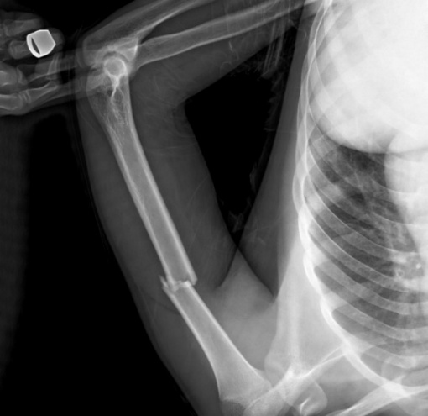
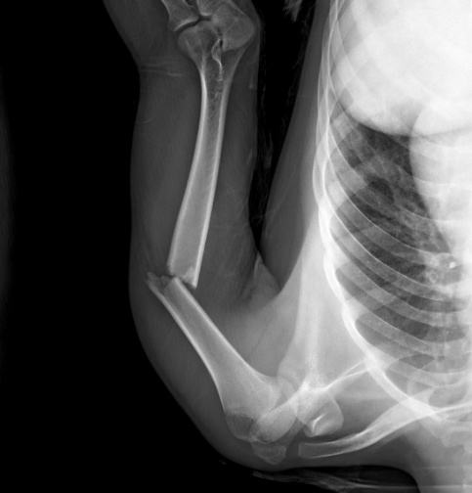
Case 1:
Male patient, 19 years old, presented with a 1.2 A3 fracture of the left humerus according to AO classification after a road traffic accident. Anterior plating was done.
No complications were recorded. Full motion of shoulder, elbow, and wrist and union have been achieved with a DASH score of 0.8/100. As shown in Figure (1).
(A)
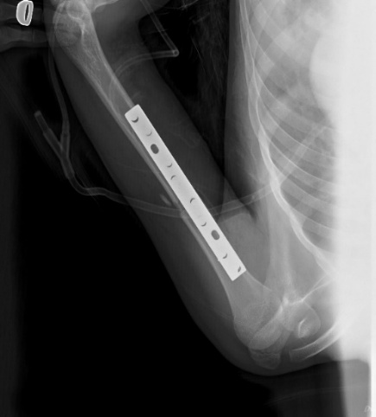
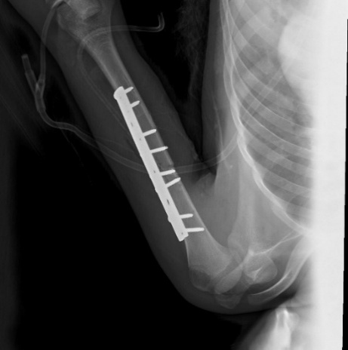
(B)

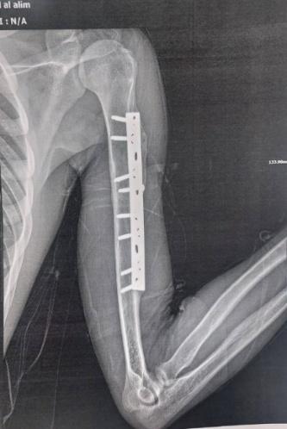
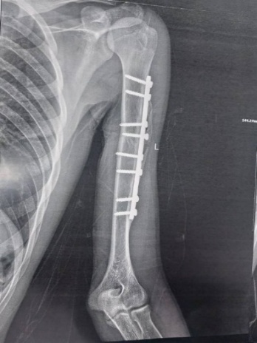
(C)

Figure (1) : A - Pre-operative X-rays, B - Post-operative X-rays, C- 6-month follow-up X-rays.

Case 2:
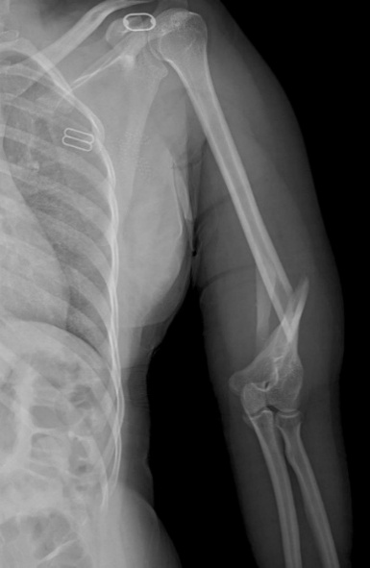
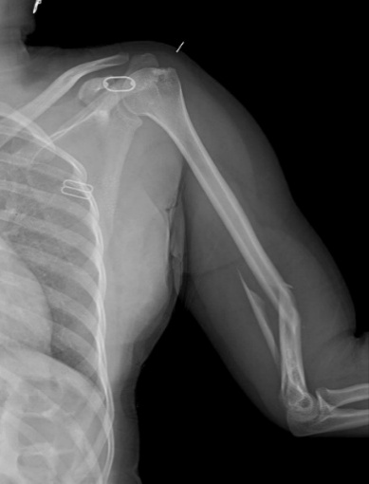
Female patient, 42 years old, presented with a Distal shaft Fragmented wedge (B3) fracture Lt humerus according to AO classification after a road traffic accident. Posterior plating was done.
(A)
No complications were recorded. Full motion of shoulder, elbow, and wrist and union have been achieved with a DASH score of 3.3/100.As shown in Figure (2).

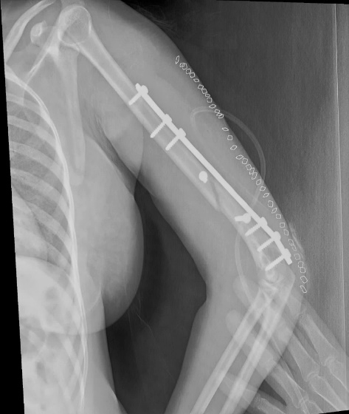
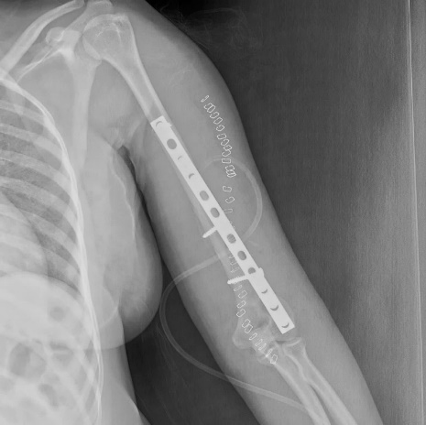
(B)

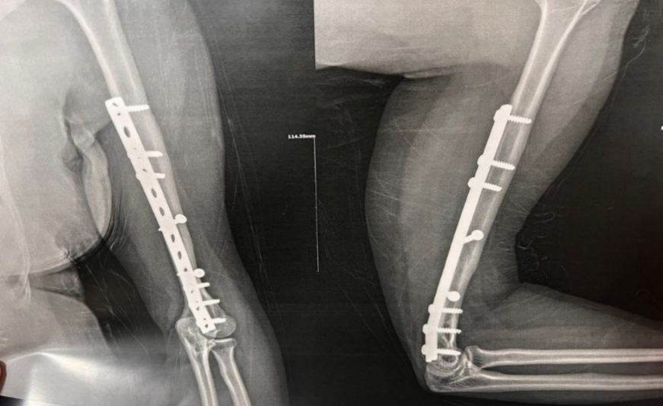
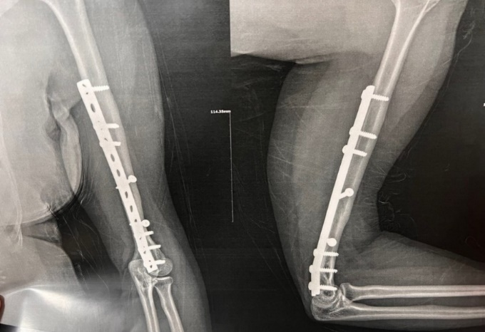
(C)

Figure (2) : A - Pre-operative X-rays, B - Post-operative X-rays, C- 6-month follow-up X-rays.

Discussion:
The annual humeral fracture incidence was 12.6 per 100,000 people, with a bimodal distribution in men and a unimodal distribution in older women.⁷
The main aim of this prospective case series study is to evaluate the incidence and consequences of radial nerve palsy in adult patients with traumatic humeral shaft fractures admitted at Assiut University Hospital, epidemiological characteristics , record the incidence of different pathoanatomic subtypes of humeral shaft fractures, management strategies and identify possible complications and outcomes. This study included 51 patients who met the inclusion criteria.
The average age in the study population was 37.39. The majority of cases were male, 41 (80.39%). These results were similar to the study of Mouraria et al. ⁸, as they reported that the mean age of the studied group was 37.9 years, with a male predominance (66.9%).
Regarding epidemiological data of humerus shaft fracture, there were 229 cases of humerus fractures, the majority of cases were surgical neck and proximal fractures 103 cases ( 44.98%), 57 cases of humerus shaft fractures (24.89%), 49 cases of distal humerus fractures (21.39%). While Bergdahl et al 2016 ⁹ reported that within the context of humerus fractures, proximal humerus injuries; being the most common account for 79%; shaft injuries account for 13%, and distal humerus fractures account for 8%.
Regarding the mode of the trauma in the current study, the majority were road traffic accidents, 35 cases (68.6%) similar to Wali et al. ¹⁰, in which Road traffic accident was the most common mode of injury. While Mattila et al. ¹¹ reported that Over 60% of humeral shaft fractures were sustained from simple falls. Most cases were closed fractures (43 cases, 84.31%) similar to Oliver’s study ⁷ (97.9%), while 3% of typical fracture were open in study of Mattila et al. ¹¹. The injury almost similarly affected both upper limbs (right and left) (rt/lt: 27/24)
According to fracture classification, the majority was type A fracture 66.67% in accordance with Oliver’s study⁷ 74.5%.
According to radial nerve palsy in this study, 8 patients had radial nerve palsy preoperatively 15.6% in accordance with Streufert et al., 2020 ¹² finding that (RNP) was present in 18%. While in Oliver’s study⁷, the incidence was 6.7% (n = 53/795 ), and in Mouraria’s study⁸ was 33%. However, there was no significant association between age, gender, open fracture, and radial nerve injury.
The aim of management, regardless of strategy, is to achieve union, appropriate alignment, and function. Traditionally, nonsurgical treatment has been the preferred approach for managing these injuries including a variety of methods that have been employed, including functional braces, U-slabs, hanging casts, Velpeau bandages, and the Sarmiento functional brace³. Regarding surgical treatment, the gold standard is open reduction and internal fixation¹³ but new techniques that achieve relative stability with preservation of the biology (intramedullary rod or osteosynthesis via MIPO technique) have increased nowadays ⁸.
In the current study, most of the presented cases were managed by posterior (64.7%) and anterior plating (13.73%).
Mouraria et al. ⁸ revealed that the surgeons mostly (73%) used osteosynthesis with DCP plate (dynamic compression plate) via the MIPO technique (minimally invasive plate osteosynthesis), followed by open reduction and internal fixation with DCP plate. The study of Westrick et al ¹⁴ revealed that out of 296 patients, 227 (76.7%) managed with surgical intervention.
The number of patients who had a union at 6 months in the study population was 48 (94.12%). The recorded postoperative complications in our study were eight patients (15.69%). 3 iatrogenic postoperative radial nerve injuries (5.88%). Two cases of infection (3.92%). 3 cases of non-union (5.88%).
These results are similar to Olson et al. ¹⁵ which reported that the overall rate of primary fracture union was 88%. Seventeen operative patients (18%) developed 17 postoperative complications: iatrogenic nerve palsy (5%), deep infection (5%), and implant failure (3%). Harkin et al.¹⁶ reported that patients managed surgically, 63% had union before 26 weeks, 33% had delayed union, and 4% did not achieve union . Closed humeral fractures were always believed to have a high union rate. Multiple studies have reported about 90% non-operative union rates. ¹⁷ .
Following up on primary radial nerve palsy cases in the study population (8 cases, 15.7%), 5 of them (62.5%) have recovered within 6 months. The other 3 cases (37.5%) were scheduled for tendon transfer. In accordance with the study of Streufert et al. 2020 ¹² which reported primary radial nerve palsy (RNP) was present in 18% of cases, 74% of them were resolved within 5.5 months, and 22% with preoperative RNP underwent tendon transfer or wrist fusion.
Regarding iatrogenic radial nerve palsy, we have 3 cases (5.88%); two of them (66.6%) have recovered within 4 months. The other one was scheduled for tendon transfer. Streufert et al. 2020 ¹² reported that iatrogenic RNP is not uncommon with humeral fracture fixation and occurs at similar rates in anterior and posterior approaches and with midshaft and distal fractures. Iatrogenic RNP had a high rate of recovery. The time to resolution was 4.1 months. ¹²
The present study showed that regarding nonunion, 3 cases of nonunion (5.88%) were reported in follow-up. Two of them were scheduled for replating, and the third patient with no complaint and refused surgery. However, some studies have reported higher nonunion rates of 13-23%. Van de Wall et al. ¹⁸ found that nonunion rate was higher in patients treated conservatively (15.3%) vs. operatively (6.4%) and The reintervention rate was also higher for conservative treatment (14.3%) than for operative treatment (8.9%).
Two cases of infection (3.92%) in the study population. Both were superficial early infections within the first 2 weeks and resolved by antibiotics. Infection rates range from 2-4%. Pidhorz et al. ¹⁹ broke these down by fixation methods and reported an average of 4% for plating, 1.6% for IM nails, and 4% for external fixation.
The study has some limitations as it was done in a single center (but it was a level I trauma center), with a short duration, so long-term complications can't be evaluated. The sample size was relatively small, so a larger one with a longer follow-up was recommended.

Conclusion and Recommendations:
This study found that the incidence of radial nerve palsy was 21.57% (11 out of 51 patients), with eight primary cases and three iatrogenic cases detected postoperatively. Of the cases, seven (63.6%) had spontaneous recovery within 4–6 months, and all of them underwent surgical exploration where the radial nerve appeared normal intraoperatively. The remaining four patients required tendon transfer surgery. Most fractures were managed using the posterior approach (33 patients), with the choice of approach depending on fracture site, comminution and nerve involvement.
To improve outcomes, standardized protocols for diagnosing and managing radial nerve palsy should be established. A structured follow-up system is needed to reduce dropouts and enhance long-term tracking. Further multicenter studies with larger samples and well-designed clinical trials are recommended to refine treatment guidelines

Conflicts of interest :
There’s no conflict-of-interest, no benefit in any form has been received or will be received related directly to this article.
Funding :
No funding was received for this research
References:
- Walker M, Palumbo B, Badman B, et al. Humeral shaft fractures: a review. J Shoulder Elbow Surg. 2011;20(5):833-844. DOI: 10.1016/j.jse.2010.11.030
- Stig Brorson MJ. Management of Fractures of the Humerus in Ancient Egypt, Greece, and Rome. Clin Orthop Relat Res. 2009;467:1907-1914. DOI: 10.1007/s11999-008-0612-x
- Sarmiento A, Kinman PB, Galvin E, Schmitt R, Phillips JJJ. Functional bracing of fractures of the shaft of the humerus. J Bone Joint Surg Am 1977;59(5):596-601. PMID: 873955
- Gallusser N, Barimani B, Vauclair F. Humeral shaft fractures. EFORT Open Rev. 2021;6(1):24-34. Published 2021 Jan 4. DOI: 10.1302/2058-5241.6.200033
- Jawa A, McCarty P, Doornberg J, Harris M, Ring D. Extra-articular distal-third diaphyseal fractures of the humerus: a comparison of functional bracing and plate fixation. J Bone Joint Surg Am. 2006;88(11):2343-2347. DOI: 10.2106/JBJS.F.00334
- Ekholm R, Ponzer S, Törnkvist H, Adami J, Tidermark JJJoot. Primary radial nerve palsy in patients with acute humeral shaft fractures. J Orthop Trauma. 2008;22(6):408-14. DOI: 10.1097/BOT.0b013e318177eb06
- Oliver WM, Searle HK, Ng ZH, et al. Fractures of the proximal-and middle-thirds of the humeral shaft should be considered as fragility fractures: an epidemiological study of 900 consecutive injuries. Bone Joint J. 2020;102(11):1475-1483. DOI: 10.1302/0301-620X.102B11.BJJ-2020-0993.R1
- Mouraria GG, Mendonça BCN, Dias AL, Zogbi DR, Cruz MA, Etchebehere MJ. Epidemiological study of surgically treated humeral shaft fractures-a 10-year review. Acta Orthop Bras. 2022;30. DOI 10.1590/1413-785220223006e256500
- Bergdahl C, Ekholm C, Wennergren D, Nilsson F, Möller M. Epidemiology and patho-anatomical pattern of 2,011 humeral fractures: data from the Swedish Fracture Register. BMC Musculoskelet Disord. 2016;17:1-10. DOI: 10.1186/s12891-016-1009-8
- Wali MG, Baba AN, Latoo IA, Bhat NA, Baba OK, Sharma S. Internal fixation of shaft humerus fractures by dynamic compression plate or interlocking intramedullary nail: a prospective, randomised study. Strategies Trauma Limb Reconstr. 2014;9(3):133-140. DOI: 10.1007/s11751-014-0204-0
- Mattila H, Keskitalo T, Simons T, Ibounig T, Rämö LJJos, surgery e. Epidemiology of 936 humeral shaft fractures in a large Finnish trauma center. J Shoulder Elbow Surg.2023;32(5):e206-e15. DOI: 10.1016/j.jse.2022.10.020
- Streufert BD, Sellers TR, Christensen JT, et al. Iatrogenic nerve palsy occurs with anterior and posterior approaches for humeral shaft fixation. J Orthop Trauma. 2020;34(3):163-168. DOI: 10.1097/BOT.0000000000001658
- Orapiriyakul W, Apivatthakakul V, Theppariyapol B, Apivatthakakul T. Humerus shaft fractures, approaches and management. J Clin Orthop Trauma. 2023:102230. DOI:10.1016/j.jcot.2023.102230
- Westrick E, Hamilton B, Toogood P, Henley B, Firoozabadi R. Humeral shaft fractures: results of operative and non-operative treatment. Int Orthop. 2017 Feb;41(2):385-395. DOI: 10.1007/s00264-016-3210-7
- Olson JJ, Entezari V, Vallier HA. Risk factors for nonunion after traumatic humeral shaft fractures in adults. JESE Inter2020;4(4):734-738. DOI:10.1016/j.jseint.2020.06.009
- Harkin FE, Large RJ. Humeral shaft fractures: union outcomes in a large cohort. J Shoulder Elbow Surg. 2017;26(11):1881-1888. DOI:10.1016/j.jse.2017.07.001
- Van Bergen SH, Mahabier KC, Van Lieshout EMM, et al. Humeral shaft fracture: systematic review of non-operative and operative treatment. Arch Orthop Trauma Surg. 2023;143(8):5035-5054. DOI: 10.1007/s00402-023-04836-8
- van de Wall BJM, Ochen Y, Beeres FJP, et al. Conservative vs. operative treatment for humeral shaft fractures: a meta-analysis and systematic review of randomized clinical trials and observational studies. J Shoulder Elbow Surg. 2020;29(7):1493-1504. DOI: 10.1016/j.jse.2020.01.072
- Pidhorz L. Acute and chronic humeral shaft fractures in adults. Orthop Traumatol Surg Res. 2015;101(1):S41-S49. DOI:10.1016/j.otsr.2014.07.034

