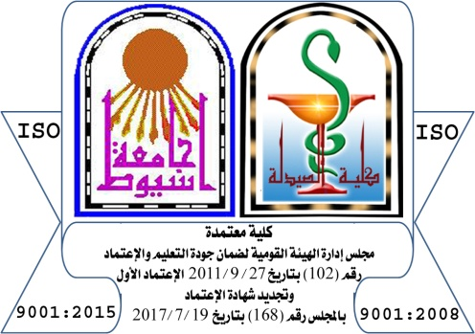


جامعة أسيوط – كلية الصيدلة  وحدة ضمان الجودة والإعتماد | Course Specification | Assuit University, Faculty of Pharmacy  Quality Assurance and accreditation Units

Course Specification of ……………………………….
Assuit University, Faculty of Pharmacy

Program on which the course is given
Major or minor element of program
Department offering the course
Department supervising the course
Academic year / level
Date of specification approval

A-Basic Information
Title: |  | Code:
Total contact hours / week |  | Lecture:
Total credit hours /week |  | Practical / tutorial

B- Professional Information
1. Overall aims of the course
Upon successful completion of this course, the students will develop various competencies based on covering the Sawing general outlines:
........................................................................................................................................................................................................................
........................................................................................................................................................................................................................
........................................................................................................................................................................................................................

2. Course learning outcomes
DOMAIN 1- FUNDAMENTAL KNOWLEDGE
1-1- COMPETENCY
Upon finishing: this course, graduates will be able to integrate knowledge from basic and applied pharmaceutical and clinical sciences to standardize materials, formulate and manufacture products, and deliver pharmaceutical care.
This competency will be developed via the following key elements:

KEY ELEMENTS
1.1.1. ............................................................................................................................................................................................
........................................................................................................................................................................................................................
........................................................................................................................................................................................................................
1.1.2. .......................................................................................................................................................................................................
........................................................................................................................................................................................................................
........................................................................................................................................................................................................................
DOMAIN 2: PROFESSIONAL AND ETHICAL PRACTICE
2-1- COMPETENCY
Graduates will be able to work as a collaborative member of an inter-professional health care team to improve the quality of life of patients and communities, and respect human rights. This competency will be developed via the following key elements:
KEY ELEMENTS
2.1.1. ......................................................................................................................................................................................................
........................................................................................................................................................................................................................
........................................................................................................................................................................................................................
2.1.2. .......................................................................................................................................................................................................
........................................................................................................................................................................................................................
........................................................................................................................................................................................................................
DOMAIN 3: PHARMACEUTICAL CARE
3-1- COMPETENCY
Graduates will be able to apply the principles of body functions to participate in improving health care services using evidence-based data. This competency will be developed via the following key elements
KEY ELEMENTS
3.1.1 ..........................................................................................................................................................................................
........................................................................................................................................................................................................................
........................................................................................................................................................................................................................
3.1.2 .................................................................................................................................................................................................
........................................................................................................................................................................................................................
........................................................................................................................................................................................................................
DOMAIN 4: PERSONAL PRACTICE
4-1- COMPETENCY
Graduates will be able to express leadership, time management, critical thinking, problem solving, independent and team working, creativity and entrepreneurial skills.
This competency will be developed via the following key elements.

KEY ELEMENTS
4.1.1 ..........................................................................................................................................................................................
........................................................................................................................................................................................................................
........................................................................................................................................................................................................................

4.1.2 .................................................................................................................................................................................................
........................................................................................................................................................................................................................
........................................................................................................................................................................................................................

3.Contents
Week | Topic | Total credit hours | Lecture | Practical/ Tutorial
 | Periodical exam
 | Final Written Exam

4.Teaching and learning methods
- Lectures ( )
- Practical training / laboratory ( )
- Seminar / Workshop ( )
- Class Activity
- Group Discussion ( )
- Teamwork Net Research ( )
- Oral Presentation ( )
- Hybridized Education ( )
5. Student assessment methods
- Written exam (periodic, final) to assess ……………………………………….
- Practical Exam to assess ……………………………………….
- Activities to assess ……………………………………….
- Oral exam to assess ……………………………………….

Assessment schedule
Assessment 1 periodical exam Week :7
Assessment 2 Practical exam Week : 13
Assessment 3 Final exam Week : 15
Assessment 4 Oral exam Week:15

Weighting or assessments
Assessment method | Marks | Percentage (%)
Written periodical Examination
Practical Examination
Final Term Examination
Oral Examination
Other types of assessment
Total
6. Facilities required for teaching and learning
........................................................................................................................................................................................................................
........................................................................................................................................................................................................................
7. List of references
- Course notes
........................................................................................................................................................................................................................
........................................................................................................................................................................................................................
- Essential books (text books)
........................................................................................................................................................................................................................
........................................................................................................................................................................................................................
- Recommended books
........................................................................................................................................................................................................................
........................................................................................................................................................................................................................

- Periodical and Websites
........................................................................................................................................................................................................................
........................................................................................................................................................................................................................
Course coordinator:
Head of Department:
Date: /20

Matrix I: Course Plan of .........................................................................................................................................
Week | Topic | Key Elements | Teaching &Learning Methods | Student Assessment Methods
 | Periodical exam
 | Final Exam

Course coordinator: Head of Department:

Date: /20

Matrix II: ………………………………………………………………….
NARS Competencies | Competencies Pharmacy Graduates | Curriculum (Topic) needs
Attributes | Competencies Pharmacy Graduates | Curriculum (Topic) needs

Course coordinator: Head of Department:

Date: /20

